

Code quality and Unit Test
Training Assignments

Document Code | 25e-BM/HR/HDCV/FSOFT
Version | 1.1
Effective Date | 20/11/2022

Contents
Objective: 4
Working Environments 4
Product Architecture 4
Technologies 4
Assignment Description 4
Exercise 1 4

 | CODE: CNU.M.A101  TYPE: LONG  LOC:  DURATION: 180 MINUTES

Technologies
The software product is developed based on:
- Java Core (OOP)
- String, int …
- S.O.L.I.D principles

Assignment Descriptions
Write a Java application for a book store.
- Each book contain title, author. Application also provide a method allow user search the book in the inventory. To apply the Single Responsibility Principle, what should you do in this in this situation?
(Write your code in package named edu.fa.solid.srp)
- Now, book store wants to hand out cookbooks at a discount price before Christmas. Create two separate classes: CookbookDiscount to hold the details of the discount and DiscountManager to apply the discount to the price. After few months, the store wants to hand out every biography with a 50% discount on the subject’s birthday. To add the new feature, create a new BiographyDiscount class and add the new functionality to the DiscountManager class. See UML graph below:
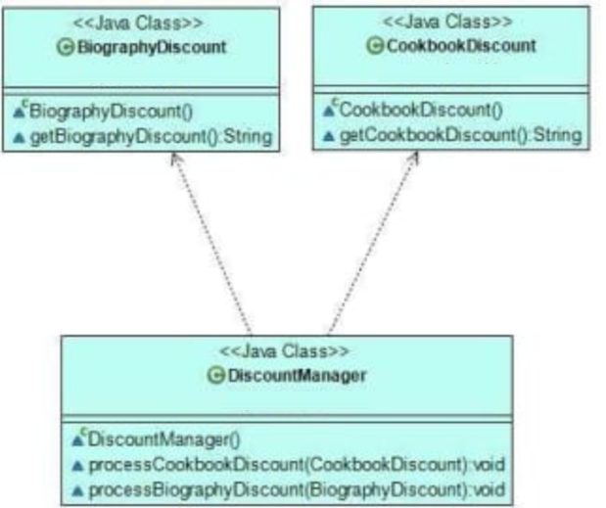
You should refactor code follows the Open/Closed principle, means that in the future, the store can extend our app with other discount types without modifying the existing code base.
khi có thêm discount của loại sách mới thì lại phải thay đổi discountManager
(Write your code in package named edu.fa.solid.ocp)
- Now, the book store wants to add a new delivery functionality to the application. Create a BookDelivery class contain title and userId that informs customers about the number of locations where they can collect their order. However, the store also sells fancy hardcovers they only want to deliver to their high street shops. So, we create a new HardcoverDelivery subclass that extends BookDelivery and overrides the getDeliveryLocations() method with its own functionality. Later, the store wants to create delivery functionalities for audiobooks, too. Now, we extend the existing BookDelivery class with an AudiobookDelivery subclass. But, when we want to override the getDeliveryLocations() method, we realize that audiobooks can’t be delivered to physical locations. See UML graph below:
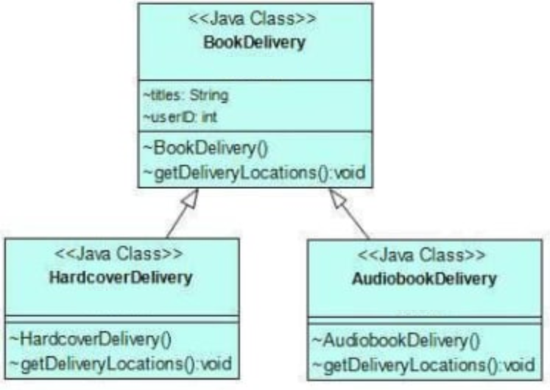
You should refactor code follows the Liskov Substitution Principle, means that you could use any subclass in place of its superclass without breaking the application.
(Write your code in package named edu.fa.solid.lsp)
- Let’s add some user actions to our online bookstore so that customers can interact with the content before making a purchase. To do so, we create an interface called BookAction with three methods: seeReviews(), searchSecondHand(), and listenSample(). Then, we create two classes: HardcoverUI and an AudiobookUI that implement the BookAction interface with their own functionalities. Both classes depend on methods they don’t use. Hardcover books can’t be listened to, so the HardcoverUI class doesn’t need the listenSample() method. Similarly, audiobooks don’t have second-hand copies, so the AudiobookUI class doesn’t need it, either. See UML graph below:
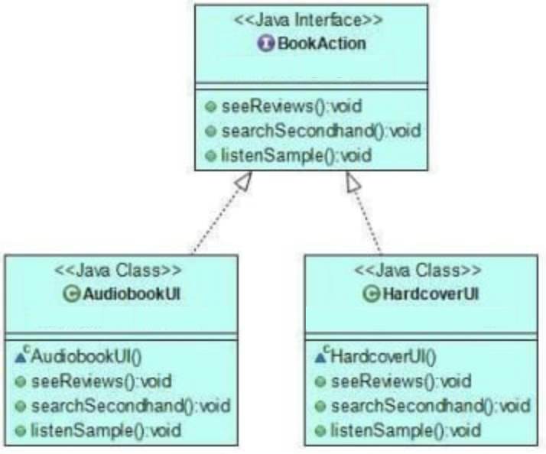
You should refactor code follows the Interface Segregation Principle, as neither classes depend on methods they don’t use.
(Write your code in package named edu.fa.solid.isp)
- Now, the book store asked us to build a new feature that enables customers to put their favorite books on a shelf. To implement the new functionality, we create a lower-level Book class and a higher-level Shelf class. The Book class will allow users to see reviews and read a sample of each book they store on their shelves. The Shelf class will let them add a book to their shelf and customize the shelf. After few months, the store asks us to enable customers to add DVDs to their shelves, too. To fulfill the demand, we create a new DVD class. See UML graph below:
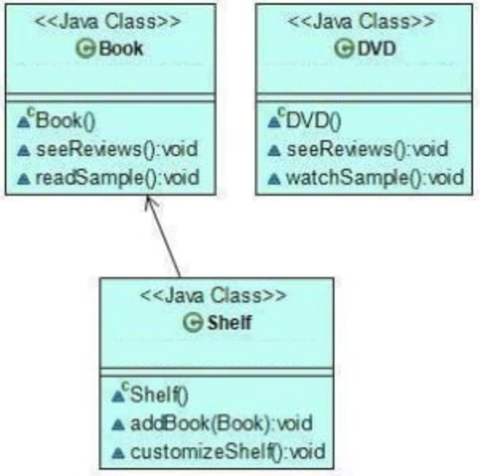
Now, we should modify the Shelf class so that it can accept DVDs, too. However, this would clearly break the Open/Closed Principle.
You should refactor code flow the Dependency Inversion Principle, as in the refactored code, high-level classes don’t depend on low-level classes, either.
(Write your code in package named edu.fa.solid.dip)

-- THE END --

